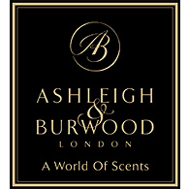
PRESS RELEASE
A World of Scents by Ashleigh & Burwood
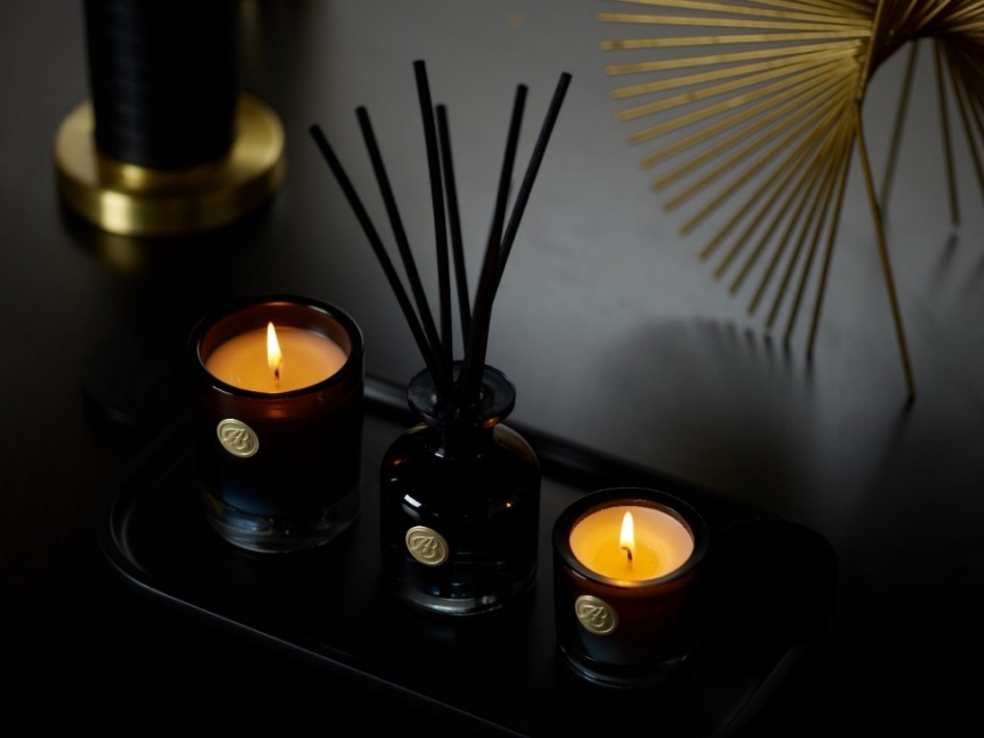
Scent experts backed by 30 years of experience in the industry, British home fragrance company Ashleigh & Burwood are taking the signature scents of their unique Lamp Fragrances to new destinations.

New premium Scented Candles and Reed Diffusers bring the powerful evocative scents of the Lamp Fragrances into these beloved home-scenting formats for the first time. Explore a curated collection of diverse fragrances, charting a luxury voyage through a ‘world of scents’ that transports you through fragrances inspired by landscapes near and far.
Ten of the brand’s most well-loved scents, including warm Moroccan Spice, clean Fresh Linen and luxurious Jasmine & Tuberose, feature in 140g Scented Candles. Burning for up to 28 hours, the candles are contained in beautiful ombre vessels of black glass, finished with a black wooden lid and gold detailing. A petite 65g Votive Candle option, with a 12 hour burn time, echoes the sophisticated design of their larger counterparts.
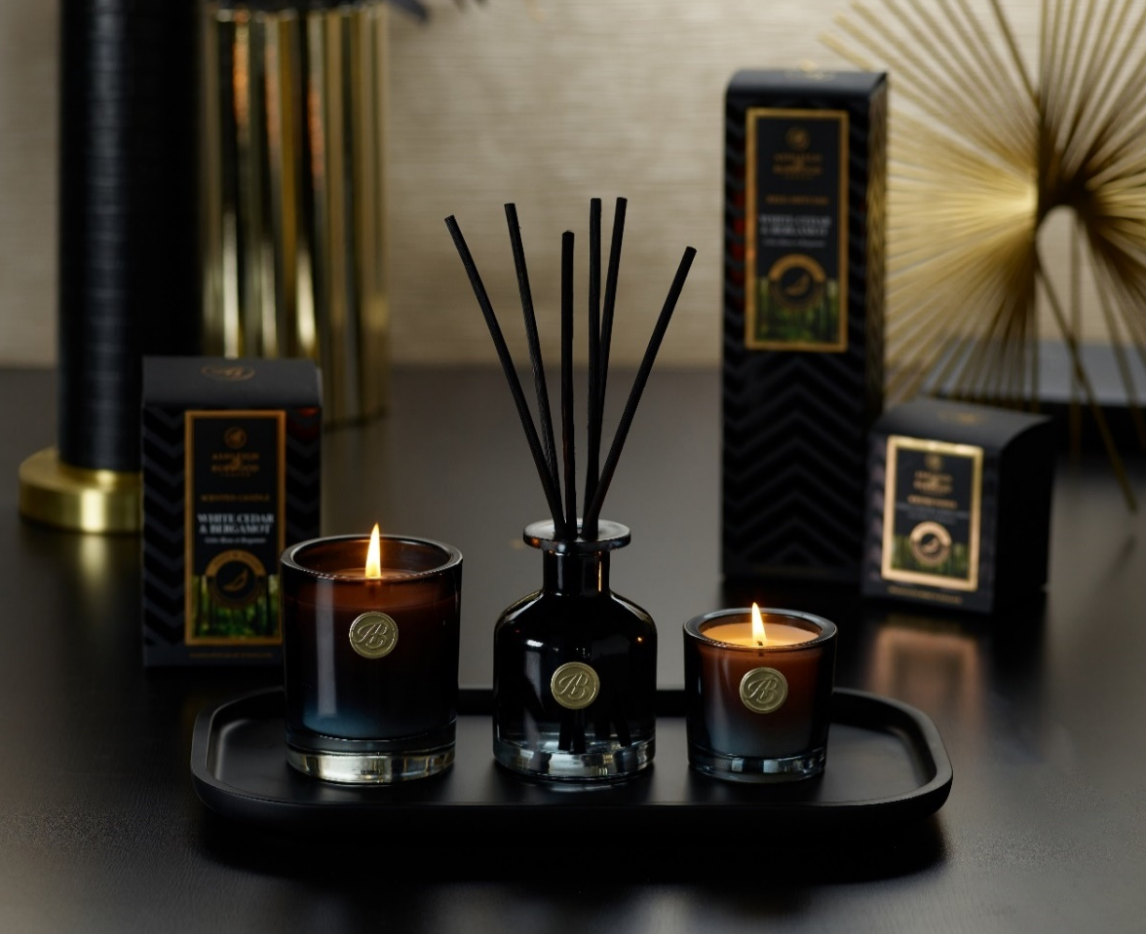
New 120ml Reed Diffusers in the same ten scents use black rattan reeds for optimal fragrance release and provide up to 10 weeks of exquisite scent. The sleek black ombre glass vessels are adorned with gold detailing, offering a luxury look using recyclable materials. The new products’ sleek and sophisticated designs and styling bring rich elegance to the home, and attractive black gift boxes add to the luxurious feel, perfect for gifting to loved ones this Christmas.
Reed Diffuser (120ml) – £25
Scented Candle (140g) – £20
Scented Votive (65g) - £12

www.ashleigh-burwood.co.uk
blog.ashleigh-burwood.co.uk

FOR MEDIA ENQUIRIES, PRODUCT SAMPLES, PHOTOGRAPHY & INTERVIEW PLEASE CONTACT THE SCENT EXPERTS:
PR Manager: Deborah Bettinson
Email: deborahbettinson@ashleigh-burwood.co.uk
Tel: + 44 (0) 1932 267060

